|  |  |
| --- | --- |
| EXP NO: 6(B) | Installation of HBase, Installing thrift along with Practice examples |
|  |
| DATE: |  |

**AIM: -**

**BACKGROUND THEORY: -**

# **PROCEDURE: -**

* Switch to superuser mode using sudo su.
* Open the HBase shell by executing the following command
* To create a table, use the create command
* To insert data into the table, use the put command.
* To retrieve data from the table, use the get command
* To scan data from the table, use the scan command
* To update a value, you can use the put command
* To delete a specific cell, use the delete command

# **CODING: -**

* sudo su
* # Start HBase shell
* hbase shell
* # Create a table
* create 'my_table', 'my_column_family'
* # Insert data (Create)
* put 'my_table', 'row1', 'my_column_family:name', 'Alice'
* put 'my_table', 'row1', 'my_column_family:age', '30'
* put 'my_table', 'row2', 'my_column_family:name', 'Bob'
* put 'my_table', 'row2', 'my_column_family:age', '25'
* # Read data (Retrieve)
* get 'my_table', 'row1'
* scan 'my_table'
* # Update data
* put 'my_table', 'row1', 'my_column_family:age', '31'
* # Delete data
* delete 'my_table', 'row1', 'my_column_family:age'
* deleteall 'my_table', 'row1' # Deletes entire row1
* # Drop the table (optional)
* drop 'my_table'

# **OUTPUT: -**

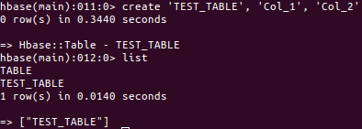

# How To Install HBase on Ubuntu (HBase Installation)